# Laboratory 9

Title of the Laboratory Exercise: Multidimensional data modelling

1. **Introduction and Purpose of Experiment**

The multidimensional data model is an integral part of On-Line Analytical Processing (OLAP).Dimensional modelling always uses the concepts of facts, measures, and dimensions.  Facts are typically (but not always) numeric values that can be aggregated. Dimensions are groups of hierarchies and descriptors that define the facts. By doing this lab, students will be able to design and implement multi-dimensional data model.

1. **Aim and Objectives**

Aim

* To design and implement concepts of multi-dimensional data modelling

Objectives

At the end of this lab, the student will be able to

* Design star and snowflake schema
* Implement multi-dimensional data modelling

1. **Experimental Procedure**
   * 1. Analyse the problem statement
     2. Design a data cube which contains a fact table and dimension table
     3. Document the Results
     4. Analyse and discuss the outcomes of your experiment
2. **Questions**
3. Design the following multi-dimensional data models for the Banking enterprise
   1. Star schema
   2. Snowflake schema
4. **Calculations/Computations/Algorithms**

**Star Schema**

**Fact Table**

**Transaction**

1. **Primary Key** 🡪 **Transaction ID**
2. **Integer** 🡪 **Account Number**
3. **Integer** 🡪 **Customer ID**
4. **Varchar** 🡪 **IFSC Code**
5. **Varchar** 🡪 **Account Type**
6. **Time Stamp** 🡪 **Date and Time**

**Dimension Tables**

**Customer (Table 1)**

1. **Primary Key** 🡪 **Customer ID**
2. **Varchar** 🡪 **Name**
3. **Multivalued Attribute** 🡪 **Contact Details**

**Account (Table 2)**

1. **Primary Key 🡪 Account Number**
2. **Double 🡪 Balance**
3. **Varchar 🡪 Account Type**

**Branch (Table 3)**

1. **Primary Key 🡪 IFSC Code**
2. **Varchar 🡪 Bank Name**
3. **Big Integer 🡪 Phone Number**

**Snowflake Schema**

**Fact Table**

**Transaction**

1. **Primary Key** 🡪 **Transaction ID**
2. **Integer** 🡪 **Account Number**
3. **Integer** 🡪 **Customer ID**
4. **Varchar** 🡪 **IFSC Code**
5. **Varchar** 🡪 **Account Type**
6. **Time Stamp** 🡪 **Date and Time**

**Dimension Tables**

**Customer (Table 1)**

1. **Primary Key** 🡪 **Customer ID**
2. **Varchar** 🡪 **Name**
3. **Multivalued Attribute** 🡪 **Contact Details**

**Customer Details (Table 2)**

1. **Primary Key 🡪 Customer ID**
2. **Varchar 🡪 Email ID**
3. **Big Integer 🡪 Phone Number**

**Account (Table 3)**

1. **Primary Key** 🡪 **Account Number**
2. **Double** 🡪 **Balance**
3. **Varchar** 🡪 **Account Type**

**Branch (Table 4)**

1. **Primary Key** 🡪 **IFSC Code**
2. **Varchar** 🡪 **Bank Name**
3. **Big Integer** 🡪 **Phone Number**

**Bank Contact Details (Table 5)**

1. **Primary Key** 🡪 **Branch ID**
2. **Varchar** 🡪 **Branch Name**
3. **Varchar** 🡪 **Branch Address**
4. **Varchar** 🡪 **Email ID**
5. **Big Integer** 🡪 **Phone Number**
6. **Presentation of Results**

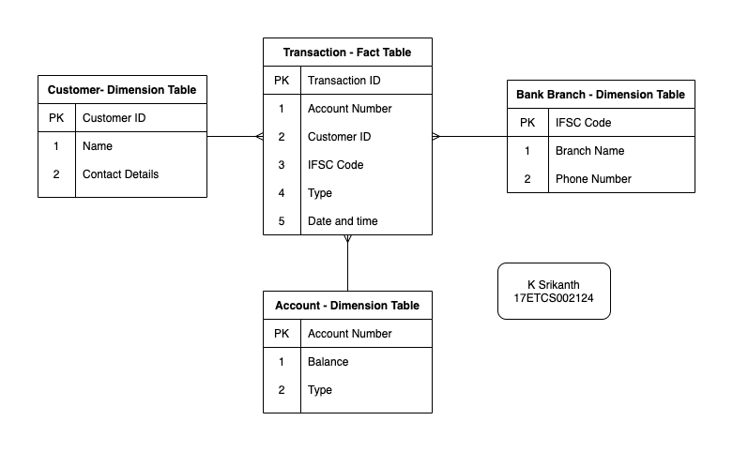

Figure 1 Star Schema for the given schema

In the following Star Schema, the fact table is at the centre which contains keys to every dimension table **like Account Number, Customer ID, IFSC Code, Type other attributes like Date and Time.**

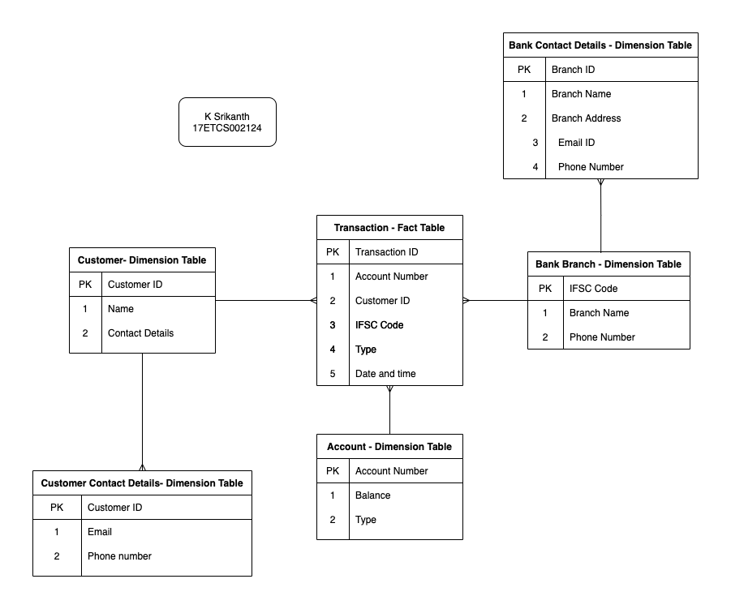

Figure 2 Snow Flake Schema for the given schema

In the following Snowflake Schema, **Customer Contact Details and Back Contact Details** is further normalized into an individual table.

1. **Conclusions**

**Star Schema**

Star Schema in data warehouse, in which the centre of the star can have one fact table and a number of associated dimension tables. It is known as star schema as its structure resembles a star. The Star Schema data model is the simplest type of Data Warehouse schema. It is also known as Star Join Schema and is optimized for querying large data sets.

**Snow Flake Schema**

Snowflake Schema in data warehouse is a logical arrangement of tables in a multidimensional database such that the ER diagram resembles a snowflake shape. A Snowflake Schema is an extension of a Star Schema, and it adds additional dimensions. The dimension tables are normalized which splits data into additional tables.

1. **Comments**

**Learning happened**

Learned how to create an **Star and Snow Flake Schema.**